

CERTIFICATE

DEPARTMENT OF COMPUTER SCIENCE

This is to certify that the project title “Online Shoes Shopping System”  
has been Successfully completed by

Mr.Jadhav Yogesh Ravindra

&

Mr.Kale Sunny Balasaheb

Student Of TYBCS for University Of Pune

During Academic Year 2020-2021

Project Guide H.O.D

Prof.Sonawane G. Prof.R.R.Gondkar

## INTERNAL EXAMINER EXTERNAL EXAMINER

A PROJECT REPORT OF

"Online Shoes Shopping System”

SUBMITTED TO,

THE UNIVERSITY OF PUNE BY,

MR.Jadhav Yogesh R.&

MR.Kale Sunny B.

UNDER THE GUIDANCE OF

PROF.SONAWANE G.

DEPARTMENT OF COMPUTER SCIENCE  
PADMASHRI VIKHE PATIL COLLEGE OF ART, COMMERCE, AND SCIENCE

TAL: RAHATA DIST: AHMEDNAGAR

INDEX

|  |  |  |
| --- | --- | --- |
| Sr.no | Name | Page no. |
| 1 | Problem Definition |  |
| 2 | Existing System And Need Of New System |  |
| 3 | Scope Of The Work |  |
| 4 | Feasibility Study |  |
| 5 | System Requirement |  |
| 6 | E-R Diagram |  |
| 7 | Data Dictionary |  |
| 8 | Class Diagram |  |
| 9 | Object Diagram |  |
| 10 | Use Case Diagram |  |
| 11 | Sequence Diagram |  |
| 12 | Activity Diagram |  |
| 13 | Collaboration Diagram |  |
| 14 | Use interface Design  Menus Input Screen using sample data Reports. |  |
| 15 | Limitations |  |
| 16 | References |  |

Problem Definition

### Online shopping is a process that has been well known only in the last few years to be precise. However, it focuses on consumers choosing their products and buying them online.

### The entire process is virtually done and there is no need for the person to be physically present at the place at the moment. It is an extensively fuss-free process which has saved a lot of precious time of people who are busy with their daily life.

### Online shopping project deals with all these online shopping sites and their proper functioning such that people can access it easily. However online shopping poses different problems.

### The quality of the product which we see online and the product we receive is often different. This creates a bad impression for the consumer. Also, delivery time may vary in the case of online shopping.

Existing System And Need of New System:-

**SYSTEM STUDY:-**

In day to day life, we will need to buy lots of goods or products from a shop. It may be food items, electronic items, house hold items etc etc. Now days, it is really hard to get some time to go out and get them by ourselves due to busy life style or lots of works. In order solve this. B2C E-Commerce websites have been started. Using these websites, we can buy goods or products online just by visiting the website and ordering the item online by mang payments online.

**An Existing System:-**

Many customers go for purchasing offline so as to examine the product and hold the possession of the product just after the payment for the product. In this contemporary world customer's loyalty depends upon the consistent ability to deliver quality, value and satisfaction. Offline shopping has a sense of immediacy You get to posses the item you've purchased the very moment. If we can search and make a list of items that we would like to try while shopping. before actually going out. This way we can be more confident in our purchase and not missing out something. This can also help us to decide what areas to visit. And plan such an event with friends.

**Limitations of Existing System**

1. . Time Consuming
2. Shipping Rates
3. . Refunds/Returns Disputes . Lack of options
4. Cash-Back offers not present
5. Bad customer service

Also there are expenses for traveling from house to shop. More over the shop from where we would like to buy something may not be open 24*7

Need Of New System:-

In order to overcome these, we have e-commerce solution, i.e. one place where we can get all required goods/products online.

Proposed Solution on System:-

To remove all the disadvantages of conventional methods, a system is proposed which is an **online shopping**.

The purpose of online shopping is to save time, save money. Through online shopping one can save his valuable time. One can watch and select things he wants to buy. Through online shopping we can save our money because prices are less than market prices and we receive our bought things at our home. No need to go anywhere and do shopping. We can get different varieties of things online and we can choose which one we want.

Through Online Shopping, a person who wants to buy is a lifestyle e-commerce web application, which retails various fashion and lifestyle products. This project allows viewing various products available enables registered users to purchase desired products instantly using PayPal payment processor (Instant Pay) and also can place order by using Cash on Delivery (Pay Later) option. This project provides an easy access to Administrators and Managers to view orders placed .In order to develop an e-commerce website, a numbers of Technologies must be studied and understood.

Scope Of The Work:-

**This product has great future scope. Internet software developed on for the Windows and later and versions environments and Linux OS. This project also provides security with the usc of Login-id and Password, SO that any unauthorized users can not use your account. The only Authonzed that will have proper access authority can access the software.**

Feasibility Study:-

The objective of feasibility study is to determine whether or not the proposed system is feasible. The feasibility is determined in terms of four aspects. These are:

**→** Technical Feasibility:-

In this, one has to test whether the system can be developed using existing technology or not. It is evident that necessary hardware and software are available for development and implementation of proposed system. We acquired the technical knowledge of working in languages, and then only we have started designing our project.

### → Behavioral Feasibility

The customers are using different types of peripherals devices. Our system is capable of providing user friendly interface for all devices (Like laptops, mobile phone).

### → Economical Feasibility

As a part of this, the costs and benefits associated with the proposed system are compared and the project is economically feasible only if tangible and intangible benefits outweigh the cost The cost for proposed online shopping system is outweighing the cost and efforts involved in maintaining the registers, books, files and generation of various reports. The system also reduces the administrative and technical staff to do various jobs that single software can do. So, this system is economically feasible

System Requirement:-

Hardware Requirement:

Processor:- min. Intel dual core

Ram:- min. 4 GB

Hard Disk:- Min. 256 GB

Software Requirement: Operation System:- Windows,Linux

Front End:- Java Script, HTML, CSS

Back End:- PGSQL

ER Diagram:-

M

**has**

**Payment**

1

M

M

**consults**

Product

**customer**

1

1

M

M

buys

**sale**

has

Manage

Manage

**Admin**

Data Dictionary:-

Admin:-

|  |  |  |
| --- | --- | --- |
| Field | Datatype | constraint |
| username | varchar | Primary key |
| password | varchar | Not null |

Customer:-

|  |  |  |
| --- | --- | --- |
| Field | Datatype | constraint |
| username | varchar | Primary key |
| phone | Varchar | Not null |
| address | Varchar | Not null |
| password | Varchar | Not null |

Product:-

|  |  |  |
| --- | --- | --- |
| Field | Datatype | constraint |
| Shoes_name | varchar | Primary key |
| Shoes_no | varchar | Not null |
| Shoes_size | Varchar | Not null |
| Shoes_price | Varchar | Not null |

payment:-

|  |  |  |
| --- | --- | --- |
| Field | Datatype | constraint |
| username | varchar | Foreign key |
| cardno | varchar | Not null |
| Shoes_price | Varchar | Not null |
| Mobile | varchar | Not null |

Sale:-

|  |  |  |
| --- | --- | --- |
| Field | Datatype | constraint |
| username | varchar | Foreign key |
| Mobile | Varchar | Not null |
| Email | Varchar | Not null |
| address | varchar | Not null |
| shoesname | Varchar | Foreign key |
| shoesprice | varchar | Not null |

Class Diagram:-

|  |
| --- |
| Admin |
| -username:varchar  -password:varchar |
| +Viewproductlist()  +Addproduct()  +Deleteproduct()  +Buydetail()  +1 |

|  |
| --- |
| Product |
| -No:varchar  #size:varchar  #price:varchar  #name:varchar |

1

1..*

|  |
| --- |
| Payment |
| #username:varchar  +mobile:varchar  -cardno:varchar  -price:varchar |

1

1

|  |
| --- |
| sale |
| -username:varchar  -mobile:varchar  -email:varchar  -address:varchar  -shoes_name:varchar  -price:varchar |

1

1

1..*

1..*

1..*

|  |
| --- |
| Customer |
| -username:varchar  -mobile:varchar  -address:varchar |
| +buyproduct()  +viewproduct()  +makepayment() |

1

1..*

1..*

1

1..*

object Diagram:-

1..*

1

1

1

|  |
| --- |
| **Product** |
| No=”12”  1  Size=”09”  1  shoesprice=”2345”  shoesname=”PUMA” |

|  |
| --- |
| Admin |
| Username=”Yogesh”  Password=”1234” |

1..*

|  |
| --- |
| customer |
| Username=”Yogesh”  Mobile=”7057081393”  1  Address=”belapur”  Password=”4144” |

|  |
| --- |
| payment |
| Username=”Yogesh”  Mobile=”7057081393”  Cardno=”1234123412”  shoesprice=”2345” |

|  |
| --- |
| Sale |
| Username=”Yogesh”  Mobile=”7057081393”  Email=”[yogeshjadhav41447@gmail.com](mailto:yogeshjadhav41447@gmail.com)”  Address=”belapur”  Shoesname=”Puma”  Shoesprice=”2345” |

1..*

1..*

1..*

1..*

1..*

1

Use Case Diagram:-

**Admin**

**Customer**

Sequence Diagram:-

**For Admin**

**D:Database**

**A:Admin**

**S:System**

Save Details

Login

Add Product

Save Details

Delete Product

Save Details

View Customer

Save Details

View Product

Save Details

View Sale Details

Logout

**For Customer**

D:Database

S:System

C:Customer

Save Details

Register/Login

Registration/Login Successfully

Save Details

View /BuyProduct

Success

Save Details

Payment

Payment Successful

Logout

Collaboration Diagram :- d

Register & login

Logout

Login

Logout

View Customer

Price

Checkout

Manage Product

Payment Done

Make Paymet

View Details

View Details

Buy Product

**S:Sale**

**P:Payment**

**P:Product**

**C:Customer**

**A:Admin**

Activity Diagram:-

Admin

No

Customer Register

No

Success?

Registered?

Yes

Yes

Add Product

Login

Delete product

View Product

View Customer product

Buy Product

Make Payment

View Product

View Sale detail

Logout

**Input Output Screen**

**(For Customer)**

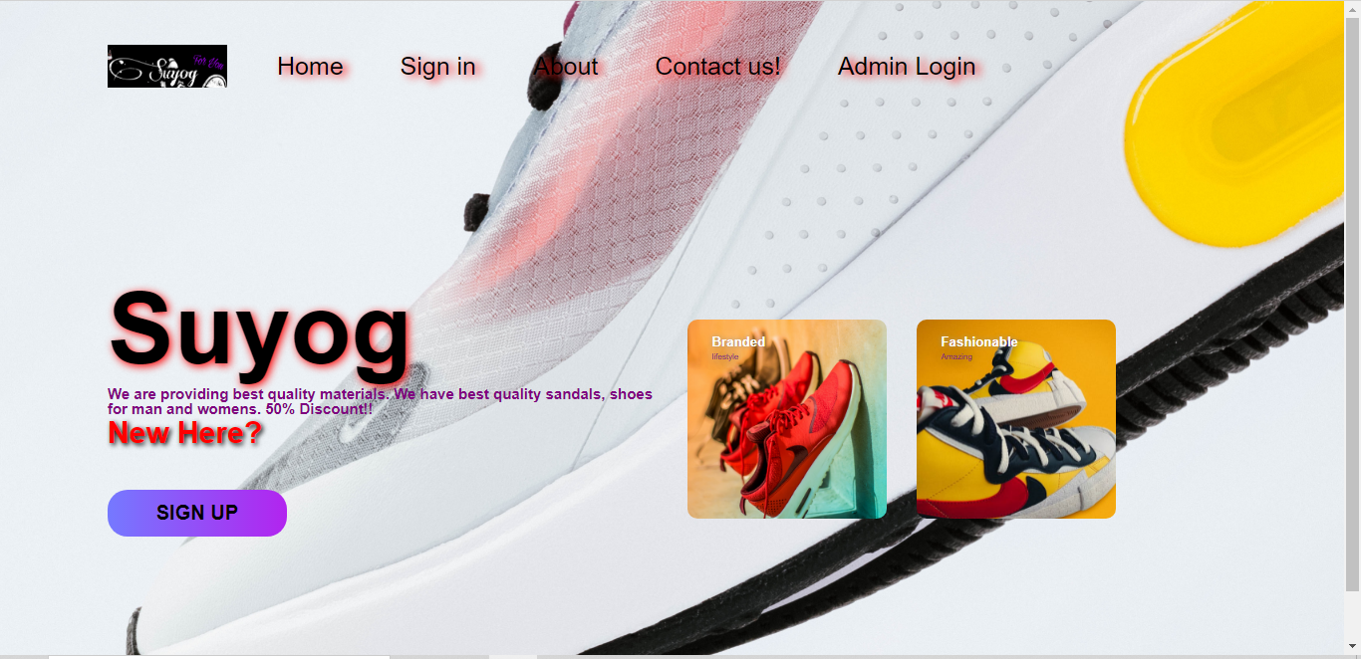

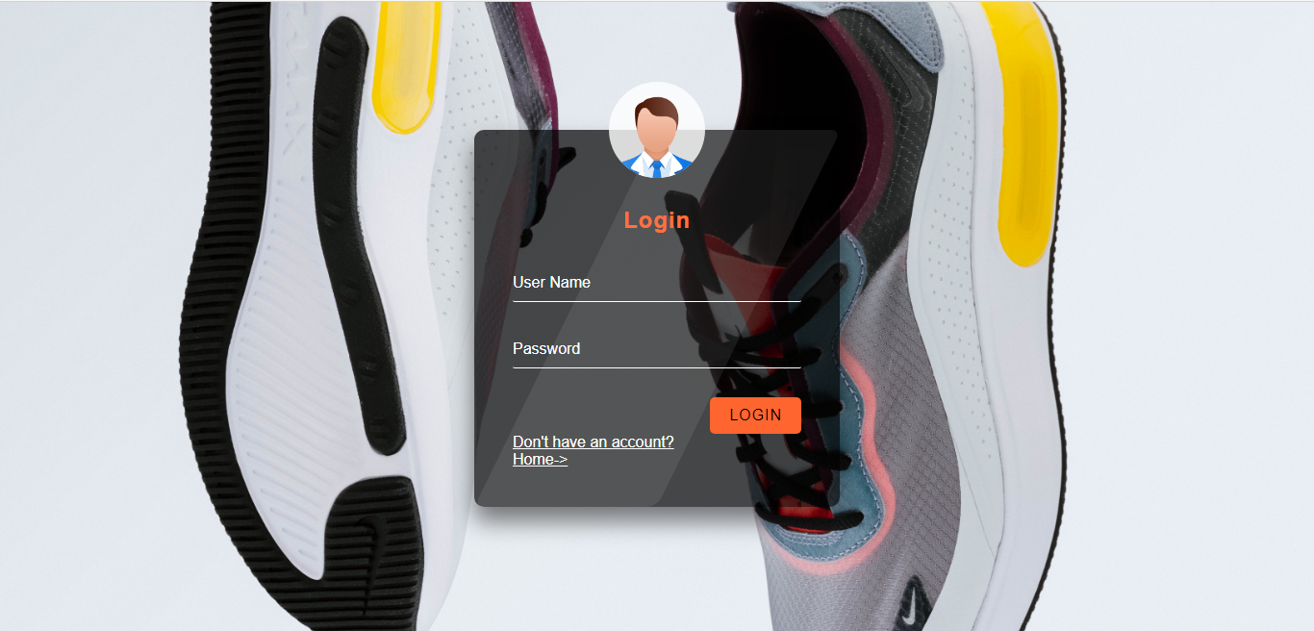

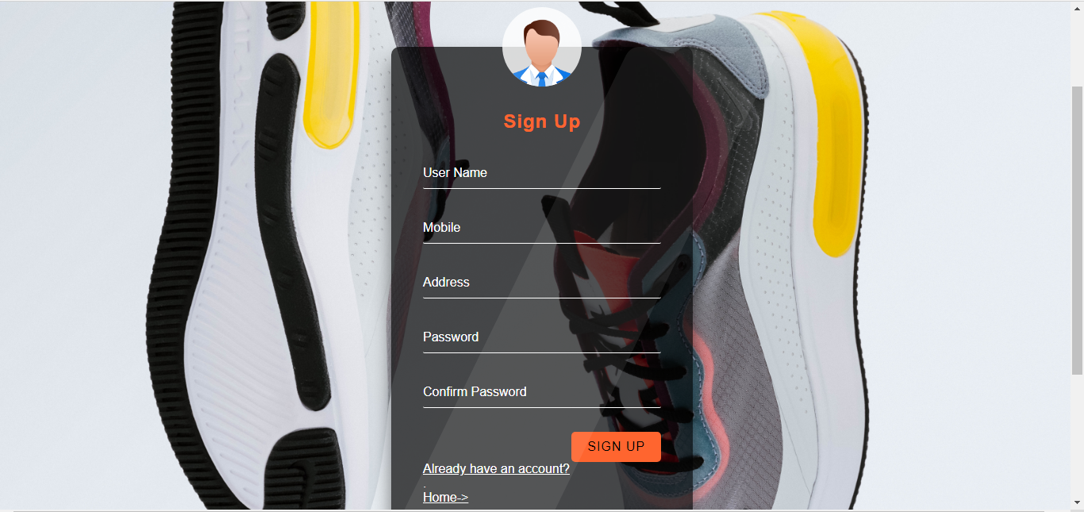

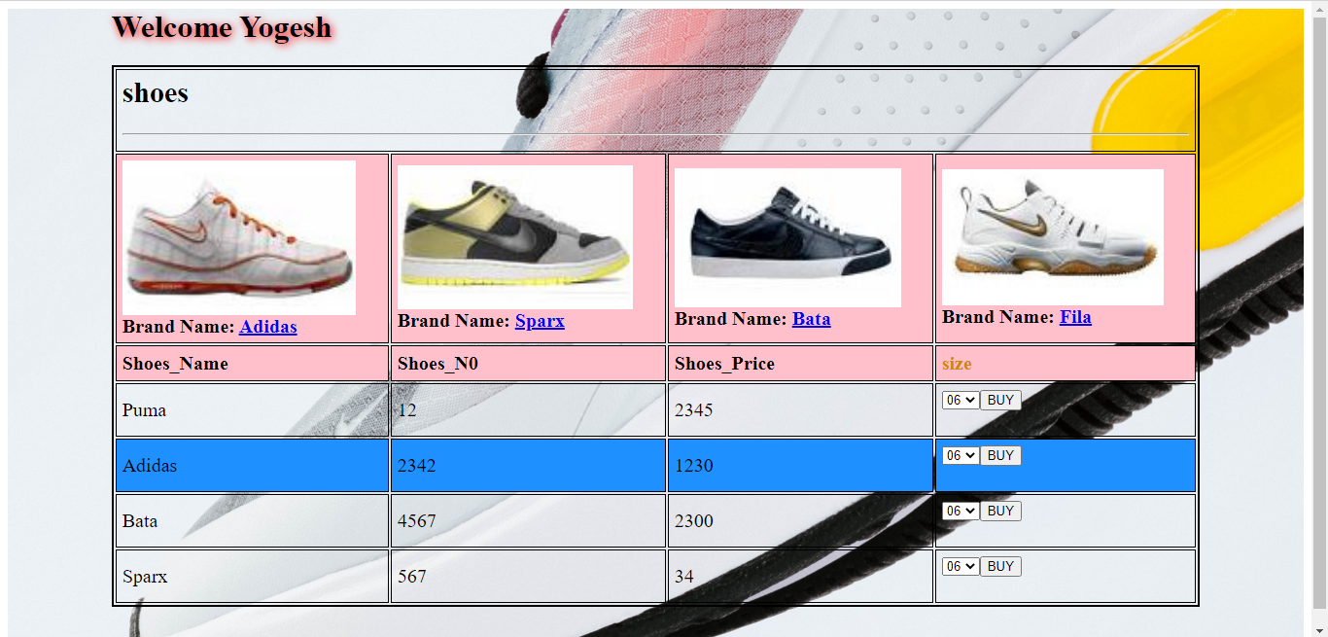

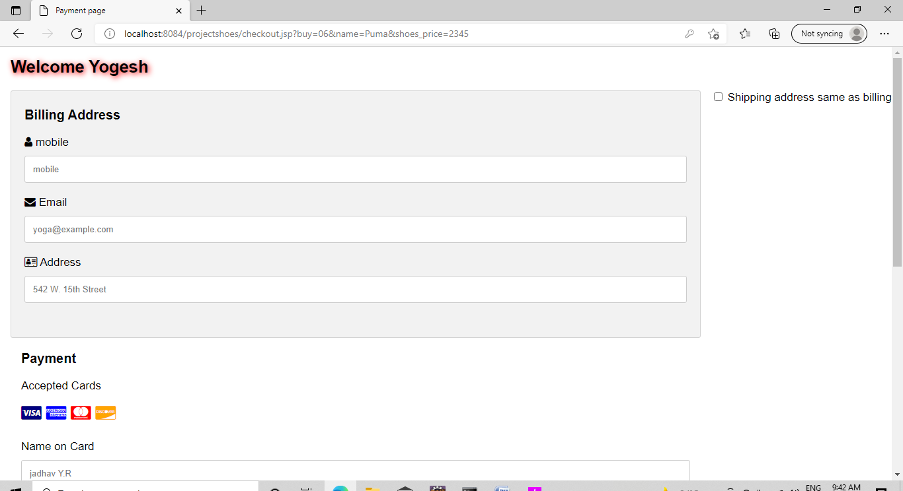

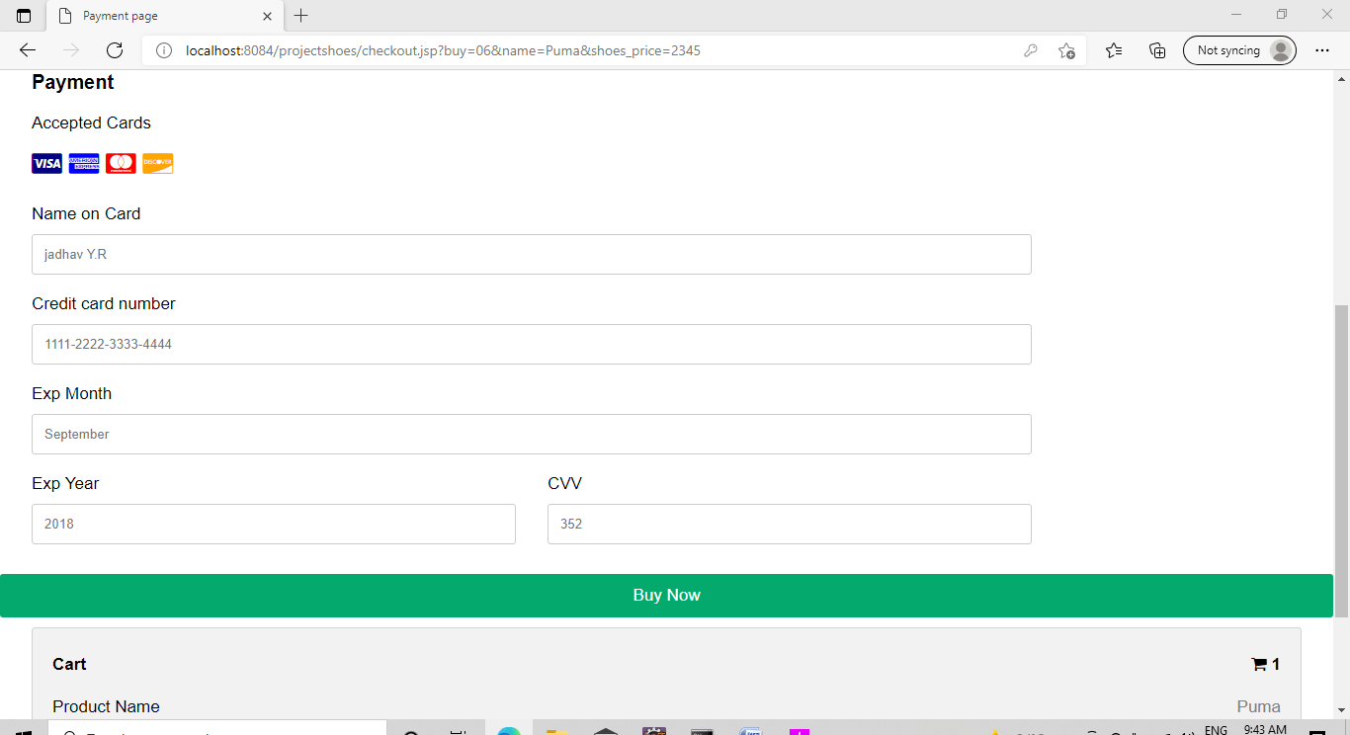

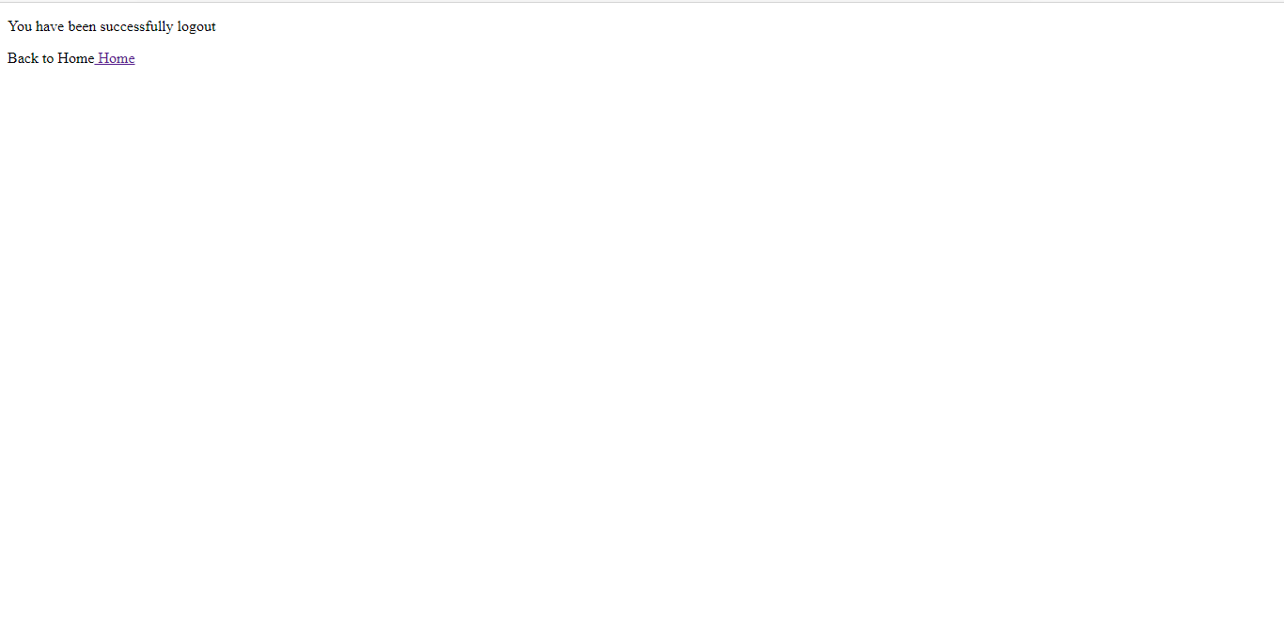

**Input Output Screen**

**(For Admin)**

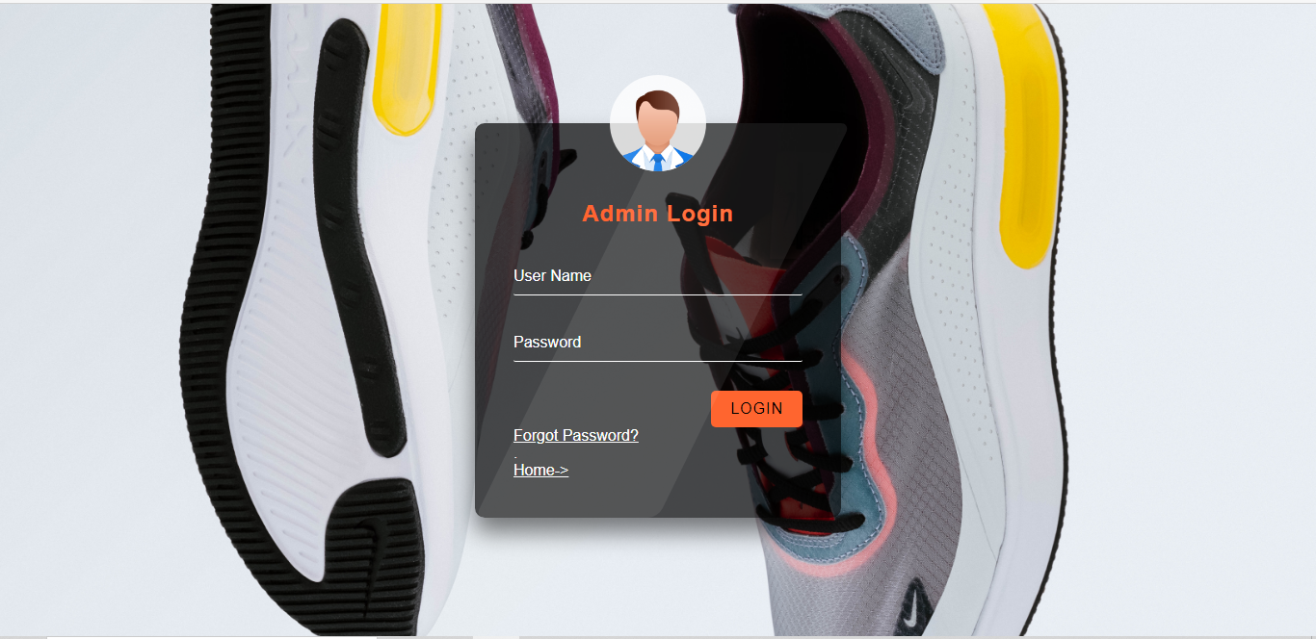

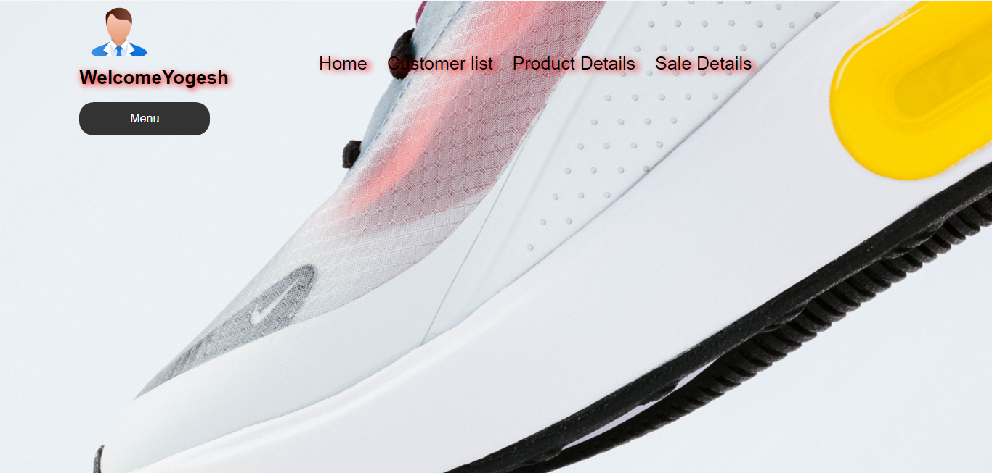

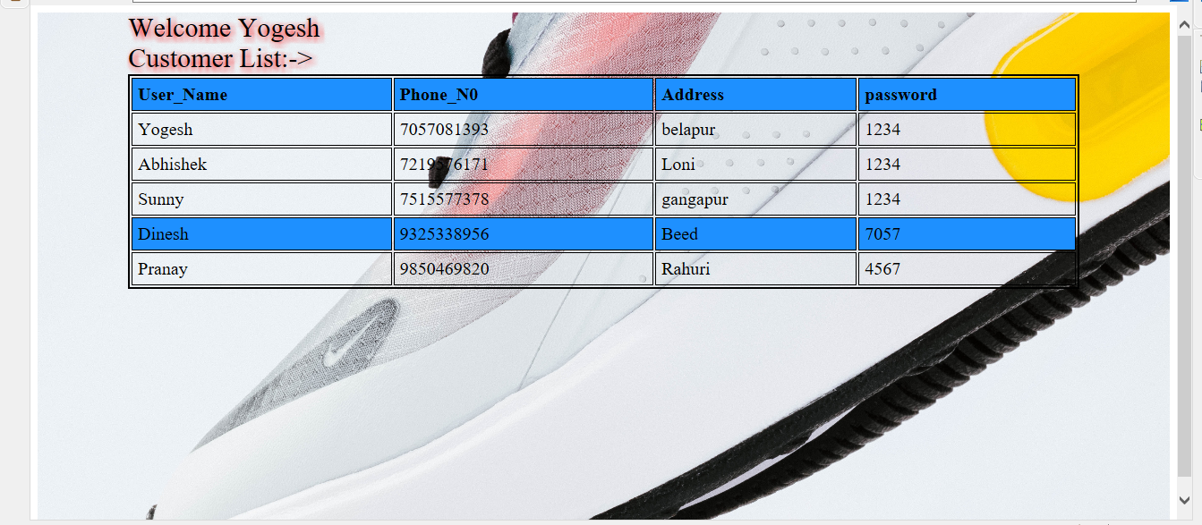

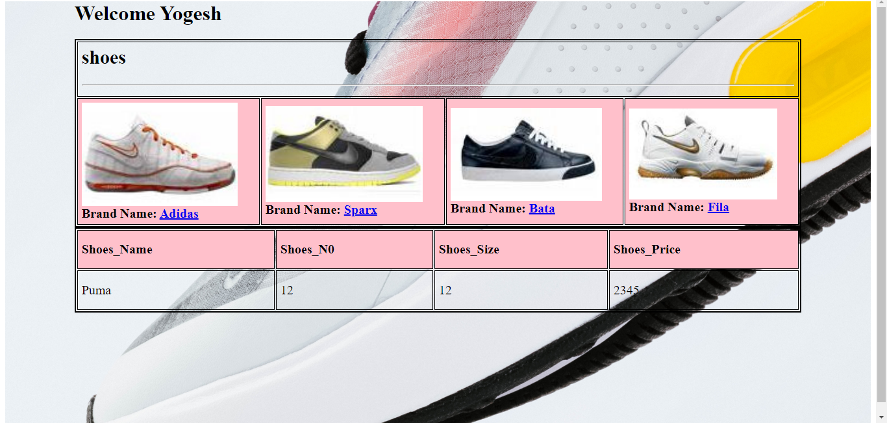

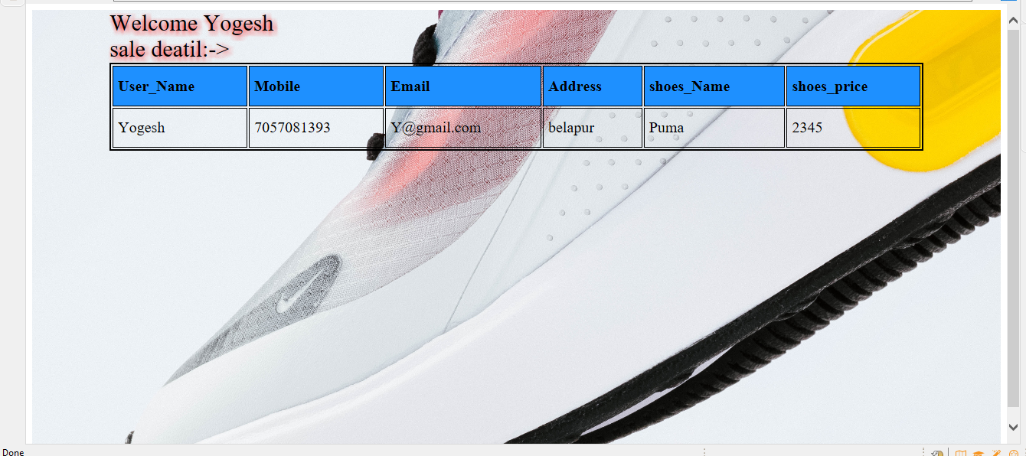

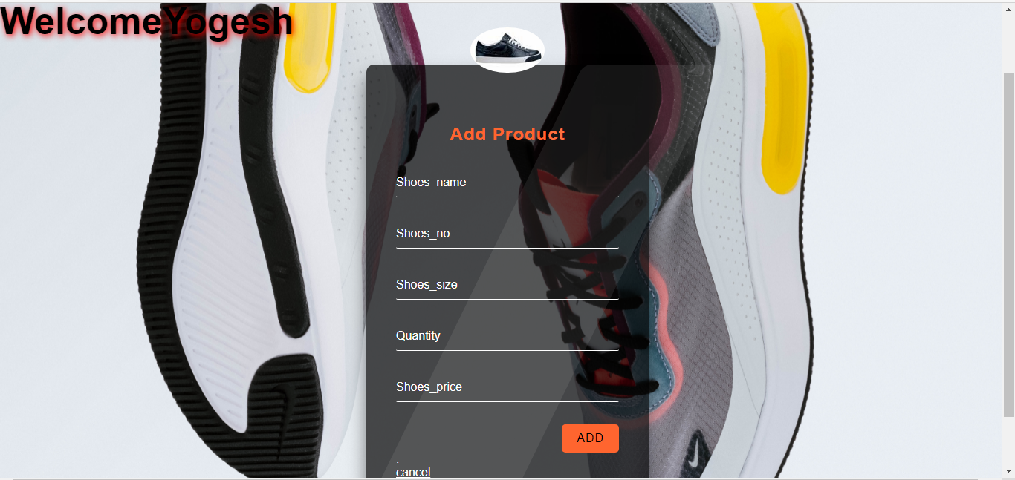

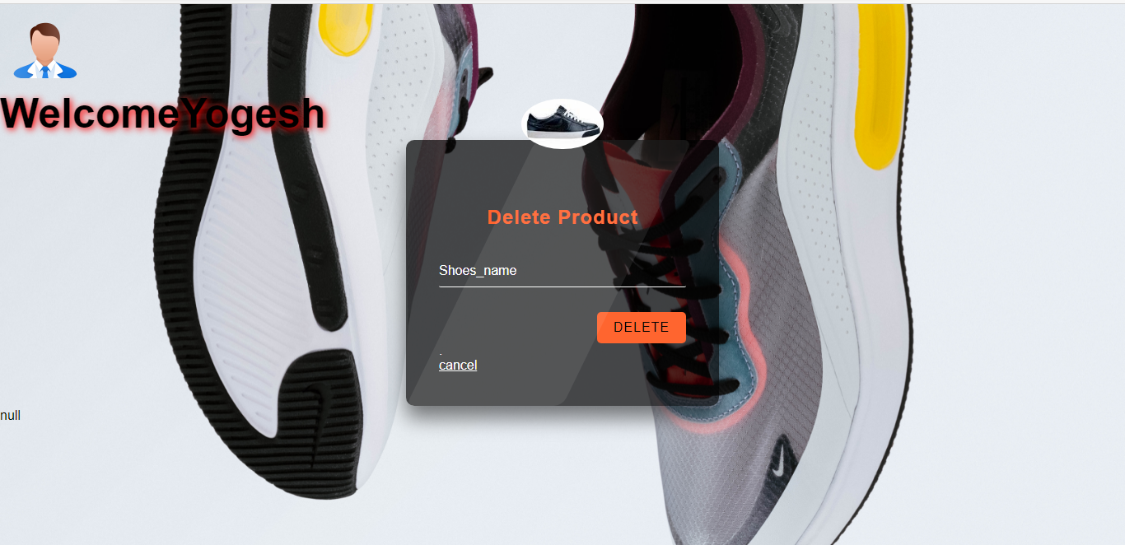



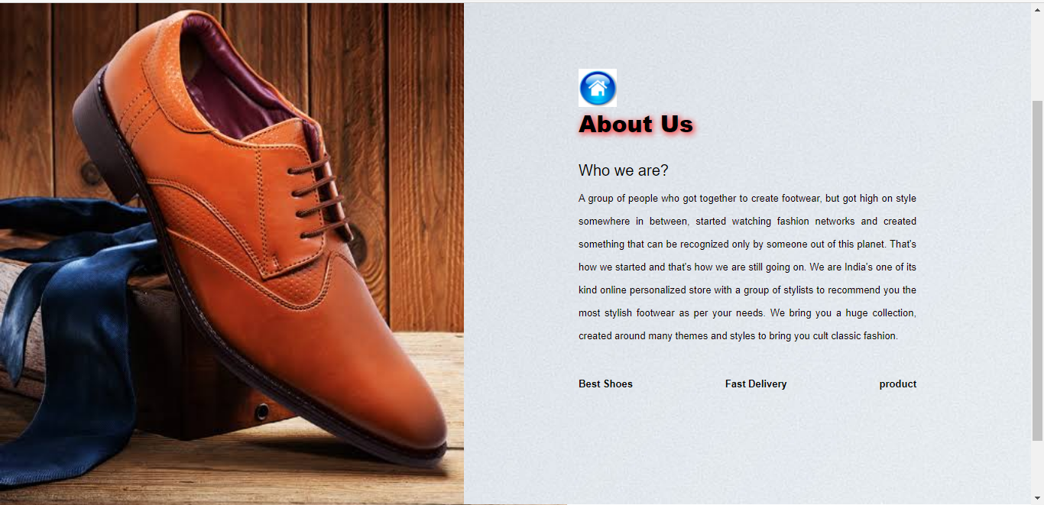

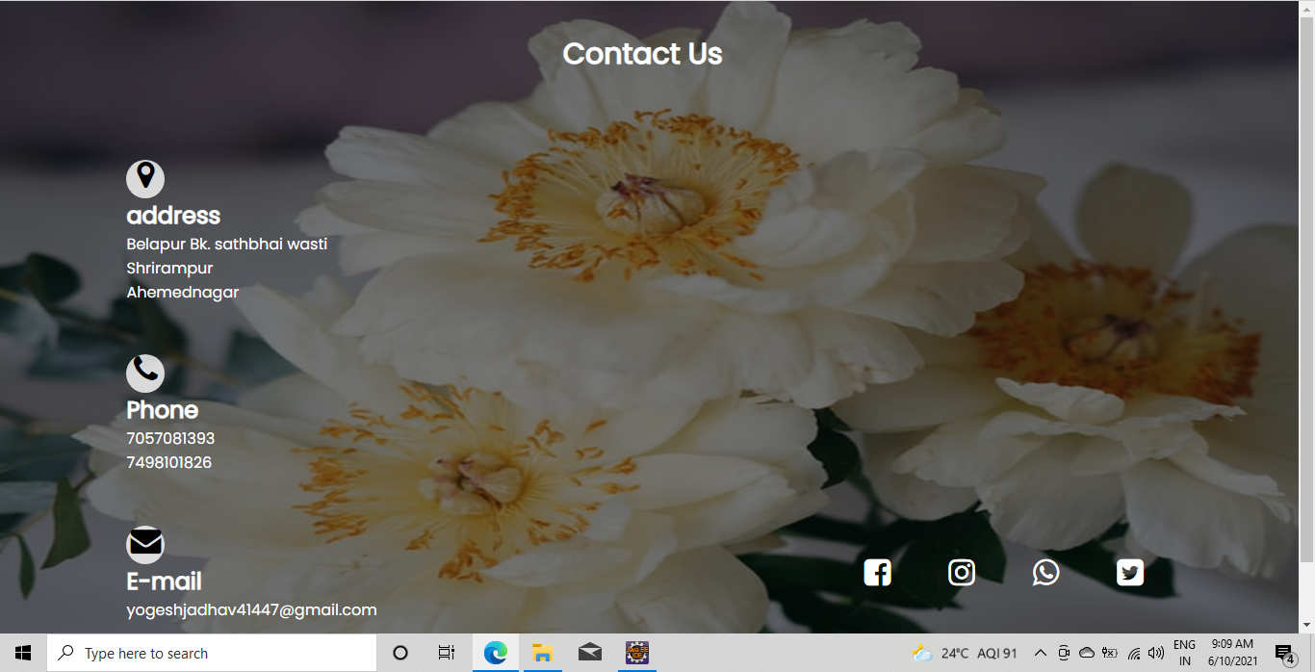Bibliography

* **Book Referred:**
* *Programming in java-II*
* ***Website Referred***
* [*www.w3school.com*](http://www.w3school.com)
* [www.amazon.com](http://www.amazon.com)
* [www.bootstrap.com](http://www.bootstrap.com)